Dear Community Neighborhood POA and HOA Boards,

As members of the Board of Directors for CT Condominium (herein after “CT Condo”) located on the south side of Babcock Avenue and west of Ferguson Ave, we are reaching out to you as it pertains to the proposed condominium development at the southwest corner of Babcock and Ferguson Avenues in Bozeman. The project, Six Range West Side Condos, is being proposed and developed by The Paine Group, Inc. and is represented by Mr. Matt Paine. The City of Bozeman Planning Department formally refers to the project as “SIX RANGE CONDOMINIUMS SITE PLAN, APPLICATION 21235”.
The purpose of this letter is three-fold:
- Contact neighboring communities of CT Condo to share recent information related to this development,
- Gauge the level of awareness, interest and/or concern by your respective Boards, owners and residents around this project and,
- Determine what, if any, collaborations might occur amongst ourselves as it relates to sharing information across our respective neighborhoods. This could include site plan submissions, findings about the development from city applications, traffic study and engineering reports, creating public awareness of the Six Range West Condos plan and encouraging public comments of concern regarding the proposed development to the City of Bozeman.
Development Descriptions:
Here is a description of the proposed property design per the engineering report from Stahly Engineering and Associates submitted on behalf of the Paine Group/Matt Paine to the City of Bozeman dated December 13, 2021 the proposed property design:
“The Six Range Condominiums Development consists of 3 large apartment buildings, 4 triplexes, and a relatively small commercial building. This project is located on a currently undeveloped 8.64-acre lot, Tract A1 of Minor Subdivision #338. The proposed apartment buildings consist of units ranging from one to three-bedrooms, and each triplex unit will be three bedrooms. The apartment buildings will provide 53 one-bedroom units, 100 two-bedroom units, and 17 three-bedroom units. The four triplexes will provide 12 additional three-bedroom units. The commercial building will provide 2500 sf of office space and 1300 sf of retail space.”
The Bozeman City Planning Department Project describes the site as follows:
“This project is a Site Plan for a multi-family development to include three apartment buildings and four three-plex buildings that will contain 182 units and approximately 7,000 square feet of commercial/retail space on 8.638 acres. The property is zoned R-O. Project Location: Property is located at 4720 West Babcock Street and legally described as Lot A1 of Minor Subdivision 338, S10, T02 S, R05 E, City of Bozeman, Gallatin County, MT.”

From a combined meeting between Mr. Paine and CT Condo owners in October, 2021, Mr. Paine shared renderings of the proposed property as well as descriptions of it as being modern, sleek architecture with predominantly 4-story buildings, one commercial office building with a coffee shop at the corner of Babcock and Ferguson, and at least four 2-story buildings facing Babcock.
Lastly, according to the Paine Group website, https://painegroup.com/investment-opportunities/, and a direct link to the Six Range West Condos marketing page, https://www.sixrange.com/,
“Six Range is an exclusive mixed living housing community created and developed by Paine Group. Six Range brings Scandinavian design and architecture to the Mountain West and invites residents to embrace the land and community around them in the neighborhood’s ample outdoor green spaces.”
“Green space expands the length of the neighborhood, more than three acres, stretching beneath elevated buildings to provide ample outdoor access and opportunities to rest, relax, recreate and gather. Outside you’ll find playgrounds, activity areas, access to trails and parks, and three expansive community roof decks.”
With the addition of three rooftop decks, this complex may give the appearance to be 5-story rather than 4-story in the middle of our mostly single and two-story homes.
The latest site plan is attached in the email with this letter. The site plan Ms. Hyde shared and delineated the eight buildings is below:
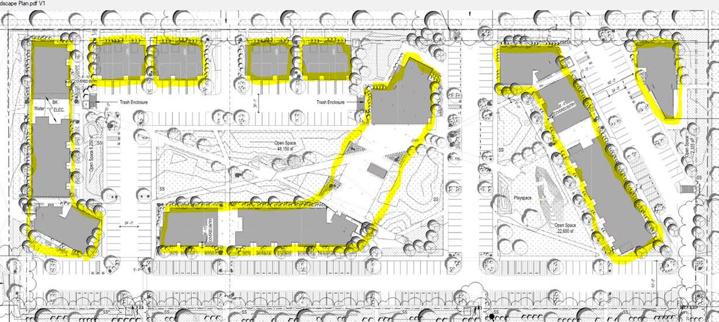

Community Impact, Application Status and Public Comment:
As you can imagine, the size, scale and proximity to the CT Condo community is a concern to many of our owners and residents. Additionally, CT Condo is facing several unique challenges with this development, none of which pertain to your areas as far as we know. That said, many of our owners and residents have expressed concerns ranging from community disruption, increased traffic, increased noise and light pollution, landscaping needs, design and aesthetics as compared to the current ‘look and feel’ of the surrounding area, property value concerns, parking threats, trash enclosure screening, parking lot locations and street safety.
To date, the application for this development is in its second application phase with the City Planning Department as the original application did not meet ‘adequacy’. Per the City of Bozeman Municipal Code, “A determination of adequacy means the application contains all of the required elements in sufficient detail and accuracy to enable the city to make a determination that the application either does or does not conform to the requirements of this chapter and any other applicable regulations under the jurisdiction of the city. Determination of adequacy will be made by the community development department.”
Ms. Lynn Hyde, Development Review Planner, Development Review Committee, lhyde@bozeman.net, is the city representative conducting much of the review work for this application. She has informed us that when the city considers any comments about a proposed project, they do so using objective measures, ideally looking at concerns that demonstrate zoning or code violations. For zoning information, Six Range is designed to meet R-O zoning, Residential-Office District. For city codes and ordinances, anyone interested in researching whether aspects of this project challenge or meet these, the link to them can be accessed via:
Code of Ordinances: https://library.municode.com/mt/bozeman/codes/code_of_ordinances
Because this development would ultimately reside in the middle of our community, we felt it important to reach out now to begin the sharing of information so that your Boards, owners and residents can begin to consider what role, if any, they may take in voicing concerns or support to the City Planning Department. CT Condominium Board, owners and residents are already engaged with hope that its disruption could be minimized through proactive outreach to Ms. Hyde now and later during the yet-to-be scheduled formal public comment period. Those interested in submitting comments to be part of the public record, can do so via emailing agenda@bozeman.net.
Please reply to contactctcondos@gmail.com if you are interested in sharing comments, concerns, information or in pursuing a collaboration of community outreach regarding this proposed development. We look forward to the opportunity to hear from you and share our experiences to date in working with the developer and the city.

Sincerely,

CT Condominium Board of Directors

Bozeman Municipal Code, Municode accessed here on 1-22-2022 https://library.municode.com/mt/bozeman/codes/code_of_ordinances?nodeId=BOZEMAN_MUNICIPAL_CODE

